Arab Academy for Science, Technology, and Maritime Transport College of Computing and Information Technology
Smart Village

HADES: A two-stage intelligent IDS that quickly filters normal traffic and accurately classifies malicious attacks for efficient network security.
A Thesis submitted in partial fulfillment of the requirements of B.Sc. in cybersecurity

By
Hala degol 221027714
Hagar Mahmoud Fathy Soliman 221027652
Hagar Ahmed Abosamra 221010332
Abdulkarim Mustafa Byloneh 221027602
Osama zaid 221007729

College of Computing and Information Technology, AASTMT

Supervised By
Dr. Ahmed Maher

Smart Village, Cairo, 2025-2026

Abstract

As cyber threats become more frequent, traditional security systems often struggle to keep up because they waste valuable computing power analyzing every single piece of network traffic in deep detail. Since the vast majority of traffic is actually safe, this "examine everything" approach is inefficient and slows

down the network.

This project introduces a smarter, two-stage Intrusion Detection System designed to save resources without lowering security standards. We call this the "Binary-to-Multiclass" approach:

Stage 1 (The Gatekeeper): This is a lightweight, ultra-fast filter. Its only job is to quickly glance at network traffic and answer a simple question: "Is this safe or suspicious?" Safe traffic is immediately allowed through, requiring almost no processing power.

Stage 2 (The Analyst): This smarter, deeper artificial intelligence is only triggered when the Gatekeeper spots something suspicious. It performs a detailed investigation to identify exactly what kind of attack is happening (such as a password theft attempt or a service crash attack).

By filtering out the noise first, this system allows organizations to run high-level security checks much faster and more cheaply than traditional methods, ensuring that computing power is spent only where it is truly needed.

Acknowledgment

We wish to express our sincere gratitude to all those who have supported us throughout the journey of this graduation project.
First and foremost, we offer our deepest appreciation to our supervisors, DR. Ahmed Maher, for their invaluable guidance, insightful feedback, and unwavering support. Their expertise and encouragement were instrumental in shaping the direction of this research and overcoming the many challenges we faced.
We would also like to thank the faculty and staff of the College of Computing and Information Technology at AASTMT (Smart Village) for providing the academic foundation and resources necessary to complete this work.

Our heartfelt thanks go to our fellow teammates. This project was a collaborative effort in the truest sense, and its success would not have been possible without the dedication, hard work, and shared
vision of every member.

Finally, we extend our gratitude to our families and friends for their constant encouragement, patience, and understanding during the long hours and stressful periods of this endeavor. Their support was our foundation.

Table of Contents
Abstract 2
Acknowledgment 3
List of Figures 6
List of Tables 7
Abbreviations 8
Symbols 9
Chapter 1 - Introduction 10
1. Motivation 10
2. Problem Statement 10
3. Objectives 10
4. Problem Complexity 10
5. Constraints 11
6. Standards 11
7. Feasibility Study and Business Canvas 12
8. Thesis Organization 12
Chapter 2 - Background 3
1. Add sections as required. 3
Chapter 3 - Related Work and Similar Systems 4
1. Related Work 4
2. Similar Systems 4
Chapter 4 - Analysis 5
Software Requirements Specifications IEEE 830 5
Chapter 5 - Design 6
1. Design Alternatives 6
2. UML Diagrams 6
3. Technologies and Tools Used 6
4. Prototype 6
Chapter 6 - Implementation 7
1. Implementation Environment 7
2. Add sections as required. 7
3. Results and Discussion 7
Chapter 7 - Testing 8
Software Test Plan IEEE 829 8
Chapter 8 - Conclusion and Future Work 9
References 9
Appendix A - Senior Project Summary Report 10

List of Figures

Figure No. | Caption | Page
Figure 1.1 | Business Model Canvas for H-IDS | 12
Figure 2.1 | General Machine Learning Development Pipeline | 13
Figure 3.1 | Comparison of IDS Methodologies and the Hybrid Gap | 15
Figure 5.1 | H-IDS Activity Diagram showing the process flow | 22
Figure 5.2 | Use Case Diagram for the Security Analyst | 23
Figure 5.3 | H-IDS Block Diagram (High-Level Architecture) | 24
Figure 5.4 | Entity Relationship Diagram (ERD) for Database Schema | 25
Figure 5.5 | Sequence Diagram for Traffic Analysis Workflow | 26
Figure 5.6 | State Machine Diagram for System States | 27
Figure 5.7 | H-IDS Dashboard Sitemap Structure | 30
Figure 5.8 | Real-time Monitoring Dashboard Interface | 31
Figure 5.9 | Attack Analysis & Alerts Panel Interface | 31

List of Tables
Table No. | Caption | Page
Table 1.1 | Engineering Standards Applied (IEEE 830, IEEE 829, UML 2.5) | 11
Table 1.2 | Thesis Organization and Chapter Breakdown | 12
Table A.1 | Senior Project Summary Report | 40

Abbreviations
Abbreviation | Meaning
AI | Artificial Intelligence
API | Application Programming Interface
CPU | Central Processing Unit
CSV | Comma-Separated Values
DFD | Data Flow Diagram
DoS | Denial of Service
DPI | Deep Packet Inspection
EDR | Endpoint Detection and Response
ERD | Entity Relationship Diagram
H-IDS | Hierarchical Intrusion Detection System
IDE | Integrated Development Environment
IDS | Intrusion Detection System
IEEE | Institute of Electrical and Electronics Engineers
ML | Machine Learning
MSSP | Managed Security Service Provider
RAM | Random Access Memory
SIEM | Security Information and Event Management
SOC | Security Operations Center
SRS | Software Requirements Specification
TTP | Tactics, Techniques, and Procedures
UML | Unified Modeling Language
VS Code | Visual Studio Code

Symbols

a | distance | m
P | power | W (Js⁻¹)

ω angular frequency rads⁻¹

Chapter 1 - Introduction

The internet is under constant attack, and traditional security systems often struggle to keep up with the sheer volume of threats. While modern artificial intelligence is powerful, using it to analyze every single piece of digital traffic is incredibly slow and expensive, especially since most activity is actually safe. This project solves that problem by creating a smart, two-stage security system designed for efficiency. First, a fast and simple "Gatekeeper" quickly scans traffic to separate normal activity from potential threats. Then, a detailed "Analyst" is triggered only when danger is detected, looking deeply at the attack to identify exactly what it is. This approach stops the system from wasting powerful computing resources on safe data. The result is a network defense that is both incredibly fast and highly detailed, offering better protection without slowing down the system.

Motivation

The motivation for this research stems from three critical challenges facing modern network security:
1. The Efficiency Dilemma in High-Speed Networks As network traffic volumes grow exponentially, applying complex Deep Learning models to every single data packet becomes computationally unsustainable. Current systems often waste significant processing power analyzing benign (safe) traffic, which constitutes the vast majority of network activity. There is a critical need to optimize how computational resources are allocated, ensuring that heavy analysis is reserved only for data that poses a genuine risk.

1.2. The Trade-off Between Speed and Accuracy Security systems often face a compromise:
they can be fast but less precise (leading to missed attacks), or highly accurate but slow (causing network latency). This project is motivated by the need to bridge this gap. By implementing a hierarchical approach, it is possible to achieve the rapid throughput of lightweight classifiers while maintaining the high-fidelity detection capabilities of advanced neural networks.

  - Proactive Resource Management

To ensure scalability in real-world environments, security architecture must minimize "alert fatigue" and hardware strain. This project aims to demonstrate that by filtering out normal traffic at an early stage, organizations can deploy sophisticated defense mechanisms without requiring prohibitively expensive hardware infrastructures.

Problem Statement

The central problem this project addresses is the computational inefficiency inherent in modern intrusion detection architectures when applied to high-speed network environments.
While advanced machine learning models have demonstrated superior capability in identifying sophisticated and novel cyber threats, they generally require significant computational power and processing time. In standard deployments, these resource-intensive models are often applied uniformly to all incoming network traffic. However, in real-world scenarios, the vast majority of network activity is benign and does not require such complex analysis.
This lack of discrimination in the processing pipeline creates a critical bottleneck. By treating every data packet as a potential high-level threat, existing systems waste valuable computing resources on normal traffic and introduce unnecessary latency. This renders many high-accuracy detection systems impractical for real-time deployment. Consequently, there is a pressing need for a hierarchical approach that can intelligent differentiate between routine traffic and genuine threats, ensuring that computational resources are utilized efficiently without compromising security standards.

Objectives

The primary objective of this project is to design and implement a resource-efficient Intrusion Detection System (IDS) that minimizes computational overhead while maintaining high classification accuracy. The specific objectives are as follows:
- Design a Hierarchical Classification Architecture: Develop a multi-stage detection framework that logically separates traffic analysis into two distinct phases: preliminary filtering and detailed inspection.
- Develop a Lightweight "Gatekeeper" Module: Implement a fast, binary classification model capable of distinguishing between normal and malicious traffic with minimal latency, serving as the first line of defense to filter out benign data.
- Develop a Granular "Analyst" Module: Create a robust, multiclass classification model designed to trigger only on confirmed threats, providing detailed identification of specific attack categories (e.g., Denial of Service, Web Attacks) with high precision.
- Optimize Computational Resource Usage: Integrate the two modules into a unified pipeline to demonstrate a significant reduction in CPU and memory usage compared to traditional single-stage deep learning systems.
- Evaluate System Performance: Conduct comprehensive testing using standard datasets to benchmark the system’s inference speed, detection accuracy, and false-positive rates against existing non-hierarchical solutions.

Problem Complexity

This project addresses a multi-faceted engineering problem that involves navigating several conflicting constraints and technical challenges:
- Conflicting Optimization Goals (Speed vs. Detail): The system must simultaneously achieve two opposing objectives: ultra-low latency for normal traffic and high-granularity classification for attacks. Balancing the lightweight nature required for the first stage with the computational depth required for the second stage presents a significant architectural challenge.
- The "Zero-Tolerance" Requirement for False Negatives: The hierarchical design introduces a critical point of failure at the first stage. If the preliminary "Gatekeeper" incorrectly classifies a malicious packet as normal (a False Negative), the attack is immediately discarded and never reaches the second stage for analysis. Therefore, the first model must achieve near-perfect recall with limited features, a difficult task in machine learning optimization.
- Severe Class Imbalance: Network traffic data is inherently imbalanced, with benign activity vastly outnumbering malicious events. Training a multi-stage system on such skewed data requires complex data engineering and sampling techniques to prevent the models from becoming biased toward the majority class.
- Feature Dimensionality Trade-offs: Determining the optimal subset of features is complex. The first stage requires a minimal feature set to ensure speed, while the second stage requires a comprehensive feature set to distinguish between subtle attack variations. Designing a pipeline that efficiently manages these differing input requirements without causing processing delays is a non-trivial engineering task.

Constraints
This section outlines the limitations that define the boundaries of the H-IDS project. These constraints strictly influence the architectural decisions, technology stack selection, and project scope.

1.5.1 Time Constraints
- Fixed Academic Deadline: The entire development lifecycle, including research, design, implementation, and testing, is strictly bound by the academic semester timeline. The project must be completed and delivered within a 6-month period.
- Phased Development: Due to this rigid timeframe, the project prioritizes the core "Binary-to-Multiclass" pipeline functionality over auxiliary features like a commercial-grade GUI or live inline blocking.

1.5.2 Budget Constraints
- Zero-Budget Requirement: The project operates under a strict zero-budget constraint. There is no funding available for software licensing, cloud processing credits, or proprietary datasets.
- Economic Viability: While the direct financial input is zero, the project represents a significant value in engineering labor (estimated at approx. $41,690 USD in a commercial setting), requiring efficient time management to maximize this "sweat equity".

$36,000 + $1,000 + $900 + $3,790 ≈ $41,690 USD
Breakdown of Values:
$36,000 USD: Labor Cost (5 Students × 480 Hours each × $15/hr).
$1,000 USD: Hardware Depreciation (Wear and tear on 5 laptops over 6 months).
$900 USD: Operational Overhead (Electricity & Internet for 5 people).
$3,790 USD: Risk Contingency (10% safety buffer).
$41,690 USD: Total Theoretical Market Value.

1.5.3 Hardware Constraints
- Single Workstation Deployment: The system is explicitly constrained to run on a single standard workstation or laptop. It cannot utilize distributed computing clusters, cloud-based parallel processing, or enterprise-grade supercomputers.
- Resource Efficiency: Because of the single-machine limitation, the software must be lightweight. The "Gatekeeper" module is a direct response to this constraint, designed to filter traffic so the system does not consume excessive RAM or CPU resources on the host machine.

1.5.4 Software Constraints
- Open-Source Dependency: To adhere to the budget constraint, the technology stack is restricted entirely to open-source software. The project must rely on free libraries such as Python 3.9+ and Scikit-learn.
- Database Limitations: The system must avoid heavy, server-based database management systems (like Oracle or Microsoft SQL Server). It is constrained to use lightweight, serverless solutions like SQLite to ensure portability on a single machine.
- Dataset Compatibility: The system is constrained to process standardized CSV formats (specifically the CSE-CIC-IDS2018 dataset) and must handle specific data anomalies (NaNs/Infinite values) inherent to these open-source datasets.

Standards
Standard | Purpose in Our Project
IEEE 830 | Requirements: This standard gave us the rules for writing Chapter 4. It helped us list exactly what the software must do (Functional Requirements).
IEEE 829 | Testing: This standard gave us the rules for Chapter 7. It guided how we created test cases to check if our code actually works.
UML 2.5 | Diagrams: We used this standard for Chapter 5. It defines the correct symbols and shapes for drawing our system's flowcharts and design diagrams.
MITRE ATT&CK | Attack Naming: This is a global dictionary for cyber threats. We used it to correctly name and categorize the attacks (like "DoS" or "Brute Force") that our AI detects.

Feasibility Study and Business Canvas
7.1Technical Feasibility The system is built upon well-established concepts in data science and cybersecurity.

- Maturity: The hierarchical approach—combining a fast, simple model with a complex, detailed one—is a proven architectural pattern in computer science.
- Tools: The development relies on standard, open-source machine learning libraries that are stable, free, and widely supported by the developer community.
- Hardware: The project is designed to be computationally efficient. The "Gatekeeper" module drastically reduces the processing load, ensuring the system can function effectively on standard academic workstations without requiring expensive, enterprise-grade supercomputers.

-Economic Feasibility This project is economically viable with a zero-budget requirement.
- Implementation: There are no licensing fees, as the system utilizes open-source software and public academic datasets.
- Operations: The primary "cost" is computational time for training, which utilizes existing laboratory infrastructure.
- Market Viability: By reducing the hardware requirements for network security, this software has high potential value for companies looking to lower their operational expenses (OpEx).
- 7.2 Business Canvas (Conceptual)
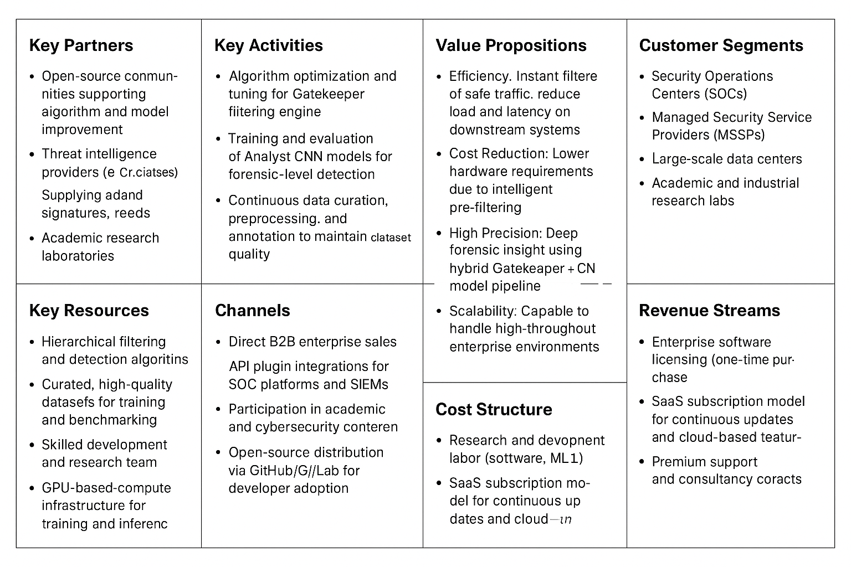
This section outlines how this technical project could be translated into a viable product in the cybersecurity market.

Thesis Organization

The thesis is organized into eight main chapters, designed to logically present the background, methodology, and results of the Hierarchical Intrusion Detection System project.

Chapter | Title | Primary Focus & Content
Chapter 1 | Introduction | Provides the context, Motivation (efficiency challenge), Problem Statement (computational bottleneck), Objectives, Constraints, and the overall scope of the project.
Chapter 2 | Background | Discusses the theoretical foundation of Intrusion Detection Systems (IDS), the concepts of Hierarchical Classification, and the fundamentals of the machine learning techniques used (lightweight models for filtering and deep models for analysis).
Chapter 3 | Related Work | Reviews existing academic literature and similar commercial systems. This chapter highlights the current gap in efficiency that your hierarchical system aims to fill.
Chapter 4 | Analysis | Details the Software Requirements Specification (SRS) , including the Functional Requirements (REQ-1 to REQ-10) for the two-stage classification and the Non-Functional Requirements (Latency, Accuracy).
Chapter 5 | Design | Describes the high-level system architecture, detailed design diagrams (DFD, Sequence Diagram) for the two-stage process, and the specific Technology Stack selected for implementation.
Chapter 6 | Implementation | Details the development process, including the environment setup, model training protocols for both the "Gatekeeper" and the "Analyst" modules, and presents the final Results and Discussion.
Chapter 7 | Testing | Outlines the Software Test Plan (IEEE 829) , defining test cases and validation results that demonstrate the system meets the performance, accuracy, and efficiency objectives.
Chapter 8 | Conclusion and Future Work | Summarizes the project's key findings, assesses whether the objectives were met, and proposes directions for future research and development.

Chapter 2 – Background and similar systems

2.1 Background and Theoretical Framework
2.1.1 Introduction
The digital landscape has evolved from a static environment of trusted entities into a dynamic, hostile battleground. As reliance on interconnected systems grows, so does the sophistication of cyber threats. This section establishes the theoretical foundations required to understand the design and operation of the proposed Hierarchical Intrusion Detection System (H-IDS).

2.1.2 Overview of Cybersecurity Principles
The fundamental objective of this system is to uphold the "CIA Triad," the governing model for information security:
- Confidentiality: Ensuring sensitive information is accessed only by authorized personnel.
- Integrity: Maintaining the consistency and accuracy of data.
- Availability: Ensuring resources are accessible when needed (preventing Denial of Service).

2.1.3 Artificial Intelligence and Machine Learning Framework
To address the limitations of traditional static security measures, this project leverages Artificial Intelligence (AI).

- Machine Learning (ML): Unlike traditional software that uses explicit rules
- (Data + Rules = Output), ML algorithms build models based on training data
- (Data + Output = Rules).
- Deep Learning: This project utilizes Deep Learning to find non-linear patterns in massive datasets, which is critical for detecting subtle correlations in network traffic that simpler systems might miss.

2.1.4 Intrusion Detection Methodologies
Detection methodologies are strictly categorized into two primary approaches:
- Rule-Based (Signature) Detection: Relies on a database of known threat fingerprints. It is highly accurate for known attacks but fails completely against "zero-day" exploits.
- Behavior-Based (Anomaly) Detection: Establishes a baseline of "normal" behavior and flags deviations. It detects unknown attacks but historically suffers from high false positive rates (alert fatigue).

2.1.5 Hierarchical Classification Model
To resolve the trade-off between speed and accuracy, this project implements a hierarchical architecture:
- The Gatekeeper (Stage 1): A lightweight binary classifier filters out benign traffic with minimal latency.
- The Analyst (Stage 2): A complex, resource-intensive model executed only on suspicious traffic.

2.1.6 Machine Learning Development Pipeline
Developing the robust AI model requires a structured pipeline:
- Data Cleaning: Handling missing values (NaNs) and removing infinite values.
- Feature Encoding: Using One-Hot Encoding to transform categorical attributes (e.g., "TCP") into numerical vectors.
- Normalization: Applying Min-Max Scaling to map features to a uniform range [0, 1].

2.2 Similar Systems and Market Analysis
2.2.1 Introduction to Market Landscape
To justify the development of Hades, it is essential to analyze the current cybersecurity market. This section reviews the Top 10 Intrusion Detection and Prevention Systems (IDPS) currently in use, ranging from open-source network monitors to enterprise-grade Endpoint Detection and Response (EDR) platforms.
2.2.2 Top 10 Market Solutions
We have selected the following ten systems as industry benchmarks. They represent the spectrum of Signature-based, Behavior-based, and Hybrid technologies.

1. Snort
- Type: Network IDS (NIDS)
- Methodology: Signature-based (Rules).
- Overview: The industry standard for open-source packet logging and traffic analysis. It uses a rule-driven language to combine inspection methods.
2. Suricata
- Type: Network IDS/IPS
- Methodology: Signature & Heuristic.
- Overview: A high-performance engine often seen as the modern successor to Snort. It features multi-threading (unlike older Snort versions) and rigid Lua scripting for complex detection.
3. Zeek (formerly Bro)
- Type: Network Security Monitor (NSM)
- Methodology: Behavioral/Metadata Analysis.
- Overview: Unlike standard IDS, Zeek generates comprehensive logs of all activity (not just alerts), allowing for deep retrospective analysis.
4. OSSEC
- Type: Host-based IDS (HIDS)
- Methodology: Log Analysis & Integrity Checking.
- Overview: Focuses on log analysis, file integrity monitoring (FIM), and rootkit detection on the host machine itself.
5. Wazuh
- Type: XDR / SIEM
- Methodology: Hybrid (Log Analysis + Threat Intelligence).
- Overview: An evolved fork of OSSEC that integrates with the ELK Stack (Elasticsearch, Logstash, Kibana) to provide a full security platform.
6. CrowdStrike Falcon
- Type: Endpoint Detection & Response (EDR)
- Methodology: Cloud-Native AI/Behavioral.
- Overview: Uses a lightweight sensor on the endpoint and a massive cloud brain to detect attack patterns (TTPs) using machine learning.
7. Darktrace
- Type: Network Detection & Response (NDR)
- Methodology: Unsupervised Machine Learning ("Enterprise Immune System").
- Overview: Uses self-learning AI to define "normal" for a network without requiring training data or rules, autonomously interrupting abnormal activity.
8. SentinelOne
- Type: EDR / XDR
- Methodology: Behavioral AI (On-Device).
- Overview: Focuses on executing AI models locally on the device (agent-based) rather than relying entirely on the cloud, enabling offline protection.
9. Cisco Secure IPS (formerly Firepower)
- Type: Enterprise NIDS hardware
- Methodology: Integrated Threat Intelligence (Talos).
- Overview: A hardware-centric solution deeply integrated into Cisco firewalls, relying on massive global threat intelligence feeds.
10. Security Onion
- Type: Linux Distribution / Platform
- Methodology: Aggregation.
- Overview: A bundled open-source distribution that combines Snort, Suricata, Zeek, and Kibana into a single stack for comprehensive monitoring.

2.2.3 Comparative Analysis: Top 10 Solutions vs. Hades
The following table compares the architectural and functional characteristics of these market leaders against the proposed Hades system.

System Name | Core Methodology | Detection Scope | Deployment | Cost / License | Transparency | Hades Comparison
Snort | Signature Matching | Known Threats Only | Network (NIDS) | Open Source (Free) | High (Open Rules) | Hades adds AI to detect unknown threats that Snort misses.
Suricata | Signature + Heuristic | Known Threats + Some Anomalies | Network (NIDS) | Open Source (Free) | High | Hades uses a hierarchical pipeline to optimize speed vs. deep analysis.
Zeek | Metadata/Behavior Logs | Post-Compromise Forensics | Network (NSM) | Open Source (Free) | High | Hades focuses on real-time blocking/alerting rather than passive logging.
OSSEC | Log Analysis / FIM | Host-based Intrusions | Host (HIDS) | Open Source (Free) | High | Hades analyzes live network traffic flows, not just static system logs.
Wazuh | Hybrid Log Analysis | Host & Cloud Workloads | Host/Cloud | Open Source / Premium | Medium | Hades is lighter weight, requiring no complex ELK stack setup.
CrowdStrike | Cloud-based AI | Zero-Day & Behavior | Endpoint Agent | Expensive (Enterprise) | Low ("Black Box") | Hades runs locally without needing constant cloud connectivity or fees.
Darktrace | Unsupervised Learning | Network Anomalies | Network Appliance | Very Expensive | Low ("Black Box") | Hades uses Supervised Learning, allowing for specific attack classification.
SentinelOne | On-Device AI | Malware & Exploits | Endpoint Agent | Expensive (Enterprise) | Low ("Black Box") | Hades is network-focused rather than process-focused.
Cisco Secure | Threat Intel Feeds | Known & Global Threats | Dedicated Hardware | Expensive (Hardware) | Low (Proprietary) | Hades runs on standard commodity hardware (Laptops/Servers).
Security Onion | Aggregation (Suite) | Full Spectrum | Dedicated Server | Open Source (Free) | High | Hades is a single integrated application, not a complex OS distribution.
Hades (Proposed) | Hierarchical Hybrid (AI) | Known + Zero-Day | Network (NIDS) | Zero-Budget | High (Auditable) | N/A

2.2.4 Justification for the "Hades" Project
The comparative analysis highlights a distinct gap in the current ecosystem:
- The "Black Box" Problem: The most effective AI systems (CrowdStrike, Darktrace) are proprietary and expensive, making them inaccessible for academic study or small-scale deployment.
- The Efficiency Trade-off: Open-source tools (Snort, Zeek) are efficient but lack the advanced AI capabilities to detect zero-day threats proactively.
Hades occupies the "Hybrid Gap". It provides the AI-driven detection accuracy of commercial EDRs (like CrowdStrike) but maintains the transparency and lightweight architecture of open-source tools (like Snort). By using a hierarchical design, Hades minimizes the computational cost of AI, making advanced security accessible on standard hardware

Chapter 4 - Analysis

4.1 Introduction
The objective of the proposed system is to develop a Hierarchical Intrusion Detection System (H-IDS) that optimizes computational resources without compromising detection accuracy. Unlike traditional single-stage classifiers that force all traffic through computationally expensive models, this system employs a "Filter-and-Analyze" approach.
This chapter details the requirements engineering process, defining the functional and non-functional constraints required to implement the Two-Stage Binary-to-Multiclass architecture.

4.2 Architectural Analysis & Workflow
The system is analyzed as a pipeline consisting of two distinct logical units: the Traffic Filter (Stage 1) and the Attack Classifier (Stage 2).
The workflow analysis implies the following logic:
- Traffic Ingestion: Network flow data is captured and normalized.
- Lightweight Preprocessing: Minimal feature extraction required for the Stage 1 classifier.
- Stage 1 Decision (The Gatekeeper):
3.1Case A (Normal): Traffic is classified as benign and discarded from the analysis pipeline to conserve resources.
3.2Case B (Malicious): Traffic is flagged and forwarded to Stage 2.
- Deep Analysis (The Analyst): Stage 2 performs extensive feature extraction and executes the complex pattern recognition model.
- Classification & Alert: The specific attack category is identified and reported.

4.4 Functional Requirements (IEEE 830)
The following requirements strictly utilize standard engineering terminology to define mandatory ("SHALL"/"MUST") and recommended ("SHOULD") behaviors. Each requirement is split to ensure atomicity.

4.4.1 Data Ingestion & Processing
- FR-01: Dataset Ingestion Interface The system SHALL provide an interface for the Security Analyst to upload and read network traffic datasets in standard CSV format (specifically the CSE-CIC-IDS2018 dataset).
  - Priority: High
  - Why: Without data input, the system cannot function or perform any analysis.
- FR-02: Input Validation The system SHOULD validate the file format and structure immediately upon upload to prevent processing errors from incompatible file types.
  - Priority: Medium
  - Why: It improves system reliability and user experience but the core analysis could technically proceed (albeit riskily) without it.
- FR-03: Missing Value Sanitization The system SHALL automatically identify and handle missing values (NaNs) by filling them with statistical averages or removing the affected rows.
  - Priority: High
  - Why: Machine learning models will crash or produce invalid results if fed incomplete data.
- FR-04: Infinite Value Handling The system MUST explicitly detect and remove infinite numerical values caused by flow calculation errors (e.g., division-by-zero) to ensure algorithmic stability.
  - Priority: High
  - Why: Essential for mathematical stability; infinite values cause immediate runtime exceptions in algorithms.
- FR-05: Categorical Encoding The system SHALL transform categorical network attributes (specifically Protocol, Flags, and Service) into numerical vectors using techniques such as Label Encoding or One-Hot Encoding.
  - Priority: High
  - Why: Algorithms operate on numbers, not text; failing to encode attributes makes analysis impossible.
4.4.2 Detection & Analysis
- FR-07: Stage 1 Binary Classification The system SHALL utilize a lightweight Random Forest binary classifier to categorize network flows as either "Normal" or "Anomalous".
  - Priority: High
  - Why: This is the core "Gatekeeper" component; without it, the hierarchical architecture does not exist.

- FR-08: Stage 1 Optimization Priority The Stage 1 model SHOULD be optimized to prioritize speed over accuracy to minimize the risk of false negatives (missed attacks) at the filtering stage.
  - Priority: High
  - Why: Critical for safety; a missed attack here is lost forever ("Zero-Tolerance"), so sensitivity is non-negotiable.

- FR-09: Benign Traffic Termination The system SHALL strictly terminate the analysis of any flow classified as "Normal" by Stage 1, excluding it from further processing.
  - Priority: High
  - Why: This mechanism drives the system's efficiency; failing to stop benign traffic defeats the project's main purpose.
- FR-10: Stage 2 Conditional Routing The system MUST route a network flow to the Stage 2 XGBoost module IF AND ONLY IF Stage 1 has classified that flow as "Anomalous".
  - Priority: High
  - Why: Enforces the architectural design ensuring heavy resources are only spent on confirmed threats.
- FR-11: Stage 2 Multiclass Analysis The Stage 2 module SHALL utilize a comprehensive feature set (greater than that of Stage 1) to perform granular classification on the suspicious traffic.
  - Priority: High
  - Why: Provides the necessary detail ("The Analyst") to identify exactly what the attack is, fulfilling the detection objective.
4.4.3 Reporting & Output
- FR-12: Attack Categorization The system SHALL classify confirmed anomalies into specific attack categories (e.g., DoS, Botnet, Web Attack).
  - Priority: High
  - Why: General alerts are insufficient for security analysts; specific labels are required for actionable response.
- FR-13: MITRE ATT&CK Mapping The system MUST map all internal classification labels to standard threat names defined by the MITRE ATT&CK global dictionary to ensure professional compliance.
  - Priority: Medium
  - Why: Ensures professional standardization, though the system could technically detect attacks without standard names.
- FR-14: Dashboard Generation The system SHALL generate an interactive dashboard using Streamlit to display real-time analysis metrics, including Total Packets and Threats Blocked.
  - Priority: Medium
  - Why: Essential for user interaction and visualization, but the backend detection core functions independently of the UI.
- FR-15: Report Export The system SHOULD provide functionality to export analysis results and logs into portable formats (CSV or PDF) for external auditing.
  - Priority: Low
  - Why: A useful convenience feature for documentation, but not critical for the immediate real-time detection of threats.

4.5 Non-Functional Requirements (IEEE 830)
- NFR-01: Speed Difference
The system SHALL ensure that the Stage 1 "Gatekeeper" scan is significantly faster than the Stage 2 "Analyst" deep check.
  - Measurement Tool: Python time module (Execution Timer).
  - Verification: Measure the processing speed. Stage 1 must take less than half the time of Stage 2.
- NFR-02: Single Computer Use
The system SHALL run effectively on a single standard computer (like a laptop) without needing powerful servers or multiple machines.
  - Measurement Tool: System Resource Monitor (Task Manager / htop).
  - Verification: Deploy on a standard laptop (e.g., 16GB RAM, i7 CPU) and verify successful execution without crashing.
- NFR-03: Crash Prevention
The system SHALL not crash or stop working if it encounters bad or damaged data rows in the input file.
  - Measurement Tool: Fault Injection (Fuzz Testing).
  - Verification: Intentionally inject 20 corrupted rows (e.g., text in number fields) and verify the system completes the rest of the file.
- NFR-04: Error Recording
The system MUST save any errors or skipped data to a log file for review, rather than ignoring them silently.
  - Measurement Tool: Log File Inspector.
  - Verification: After running the "Crash Prevention" test, check if error_log.txt exists and contains exactly 20 entries corresponding to the bad rows.
- NFR-05: Handling Large Files
The system SHALL be able to process large datasets (over 1,000 records) without becoming slow or unresponsive.
  - Measurement Tool: Load Testing Script (Stress Test)⁶.
  - Verification: Input the full CSE-CIC-IDS2018 dataset chunk (>100k rows) and verify the process finishes within a reasonable time limit (e.g., < 5 minutes).
- NFR-06: Standards Compliance
The system MUST strictly adhere to IEEE 830 for requirement definitions, IEEE 829 for testing specifications, and UML 2.5 for all system diagrams.
  - Measurement Tool: Manual Audit / Checklist Review.
  - Verification: Peer review of documentation against the official IEEE and UML standard checklists.

2. Project Stakeholders
This section identifies the individuals and entities who interact with the system or have a vested interest in its success, based on your Use Cases and Business Model.

Primary Stakeholders (Direct Users)
- Security Analysts: The primary operators of the system. They are responsible for uploading datasets (FR-01), investigating alerts generated by the "Analyst" module, and initiating model retraining.
- Network Administrators: As indicated in the system workflow, they oversee the initial data ingestion and rely on the dashboard for real-time monitoring of network health and security status.

Secondary Stakeholders (Beneficiaries & Customers)
- Security Operations Centers (SOCs): Organizations that would integrate this software to reduce "alert fatigue" and optimize their hardware usage by filtering noise before it reaches human analysts.
- Managed Security Service Providers (MSSPs): Companies that provide security as a service and require cost-effective, scalable solutions to protect multiple clients simultaneously.
- Data Centers: Large-scale infrastructure providers that benefit from the system's low computational overhead, allowing them to secure high-traffic networks without expensive hardware upgrades.

Chapter 5 - Design

5.1 Introduction

The primary objective of this chapter is to transform the Functional and Non-Functional Requirements defined in Chapter 4 into a concrete architectural blueprint. While the previous chapter focused on what the system must do, this chapter focuses on how the system will be constructed.

The system design phase decomposes the Hierarchical Intrusion Detection System into its core logical components—Data Ingestion, The "Quick Scan" Filter (Stage 1), and The "Deep Analysis" Classifier (Stage 2)—defining the relationships and interactions between them. This structural breakdown ensures that the system is modular, scalable, and capable of meeting the performance goals of efficiency and accuracy.

5.1 Design Alternatives (Iterative Design)
The architecture of the proposed Hierarchical Intrusion Detection System (H-IDS) is the result of an iterative design process. We evaluated several architectural approaches, refining the design at each stage to better meet the conflicting requirements of high efficiency (low latency) and high detection accuracy (granularity).
The following subsections detail the evolution from our preliminary design concepts to the final architecture.

5.1.1 Preliminary Design (Iteration 1): Single-Stage Deep Learning
Concept: The initial design focused purely on maximizing detection accuracy. The proposed architecture involved a single, powerful Deep Learning model (a complex Multi-Class Classifier) that would inspect every incoming network packet and categorize it directly into one of several classes (e.g., Normal, DoS, Web Attack, Botnet).
Analysis & Critique: While this design promised high accuracy, the feasibility study in Chapter 1 highlighted a critical flaw regarding efficiency.
- Computational Waste: In real-world environments, the vast majority of traffic is actually safe. This design forced the system to waste valuable computing power applying complex analysis to benign data.

- Latency: Analyzing every packet in deep detail slowed down the network significantly, making the system impractical for high-speed environments.

Conclusion: This design was rejected because it failed to meet the Performance and Resource Optimization objectives. We realized we needed a mechanism to "filter" traffic before heavy analysis.

5.1.2 Intermediate Design (Iteration 2): Signature-Based Filtering
Concept: To solve the efficiency problem of Iteration 1, we explored a hybrid approach. This design placed a traditional Signature-Based Detection engine (similar to Snort) at the front of the pipeline.
- Step 1: The signature engine quickly matches traffic against a database of known threats.
- Step 2: Only traffic that doesn't match a signature but looks "weird" is sent to the AI model.
Analysis & Critique: This improved speed but introduced a major security gap identified in Chapter 3.
- Reactive vs. Proactive: Signature-based filters are reactive; they can only stop attacks that are already known and listed in a database.
- The "Zero-Day" Risk: If a brand-new attack (Zero-Day) passed through, the signature filter would see it as "unknown" and might not flag it correctly for the second stage. This created a "blind spot" for novel attacks.
Conclusion: This design was rejected because it relied on outdated "mugshot" detection methods. We needed a filter that was fast (like a signature) but intelligent enough to spot unknown anomalies (like AI).
5.1.3 Final Design (The Solution): Hierarchical Binary-to-Multiclass Architecture
Concept: The final design addresses the limitations of the previous iterations by employing a Two-Stage Intelligent H-IDS. Instead of a signature filter, we implemented a lightweight Machine Learning model as the first filter.
- Stage 1 (The Gatekeeper): A fast, binary classification model (Random Forest) that simply asks, "Is this Safe or Suspicious?". This model is ultra-fast and requires almost no processing power.

- Stage 2 (The Analyst): A complex, multiclass model (XGBoost) that is triggered only when the Gatekeeper spots something suspicious. It performs the detailed investigation to identify the specific attack type.

Why this is the chosen design: This architecture successfully resolves the Efficiency Dilemma. By filtering out the noise (safe traffic) first, the system allows organizations to run high-level security checks much faster and more cheaply than traditional methods. It achieves the accuracy of the Preliminary Design with the speed of the Intermediate Design, satisfying all project objectives

UMLS:

Activity Diagram
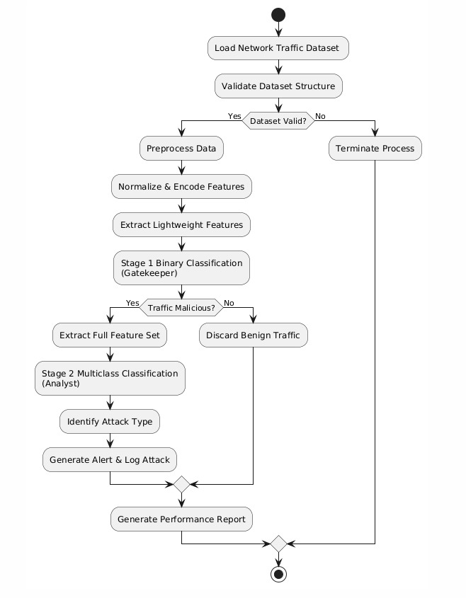

Use Case
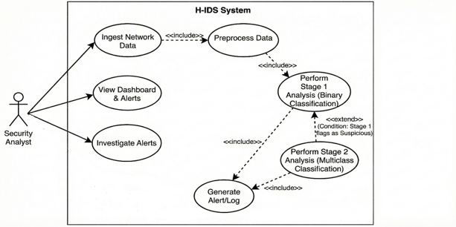

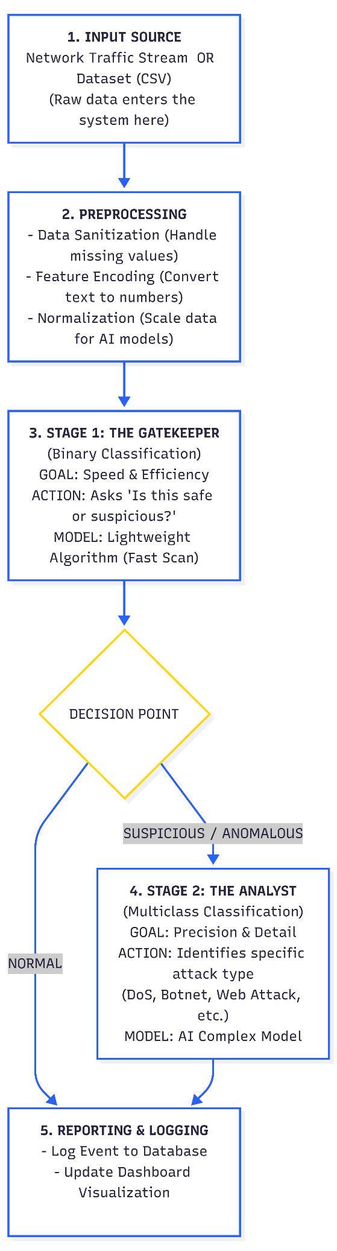
Block diagram
Entity Relationship Diagram (ERD)

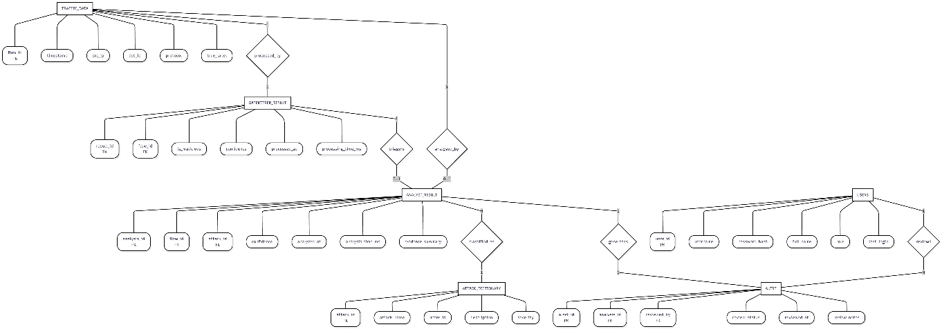

Dfd level 0:
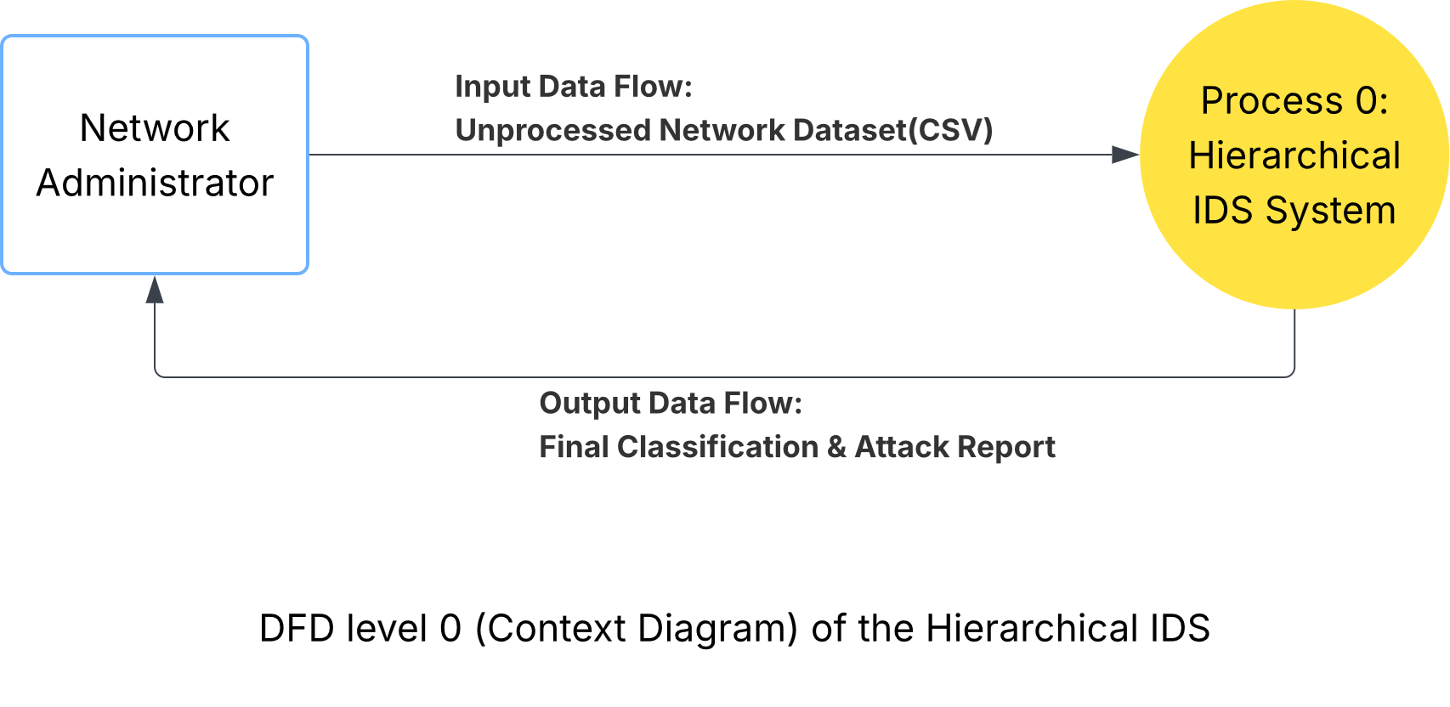
Security Analyst

Dfd level 1
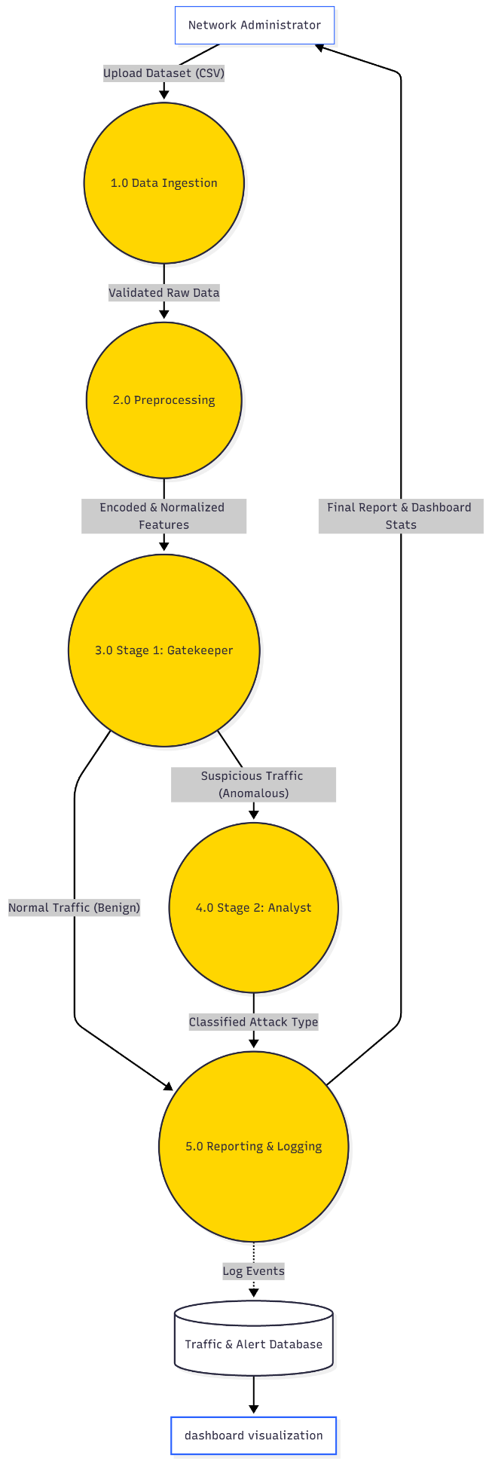
Security Analyst

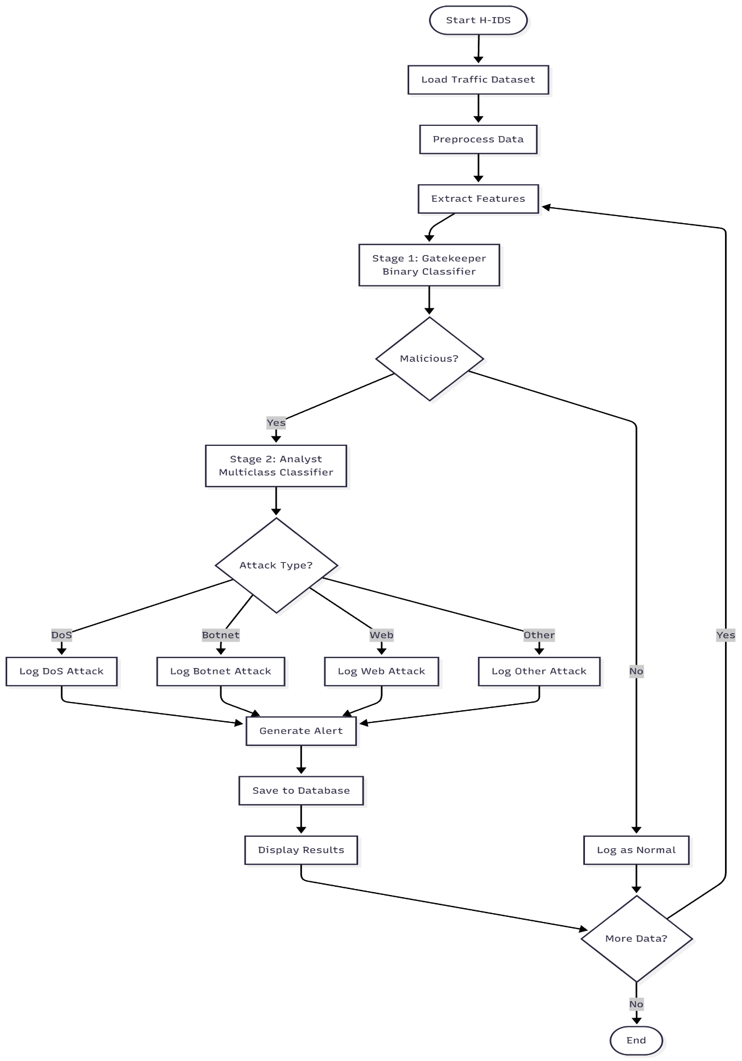
Flowchart

State machine diagram

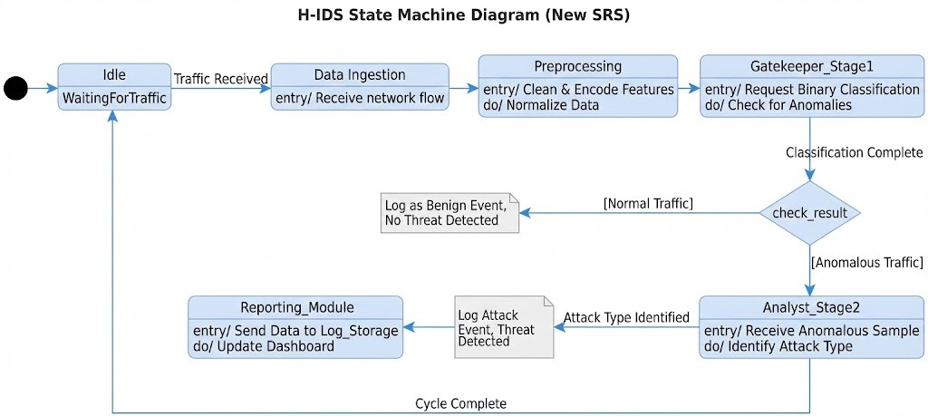

Sequence diagram:

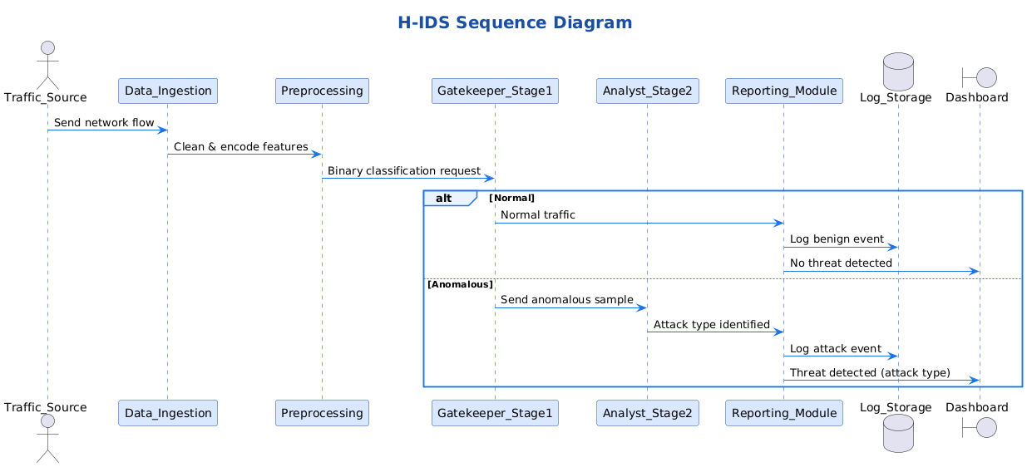

Technologies and Tools Used
This section describes the technologies and tools used to design and implement the Hierarchical Intrusion Detection System (H-IDS).
All selections were guided by the project constraints of zero cost, open-source availability, and deployment on a single workstation, while ensuring compatibility with the proposed two-stage hierarchical architecture.

The technology stack was intentionally chosen to support:
Fast binary filtering in Stage 1
Accurate multiclass attack classification in Stage 2
Leakage-free evaluation using original dataset labels
Programming Language and Development Environment
Programming Language: Python 3.9+
Python was selected as the primary programming language due to its extensive use in cybersecurity research and machine learning applications. It provides seamless integration between data preprocessing, feature engineering, model training, evaluation, and visualization.
Python’s rich ecosystem enables efficient implementation of both classical machine learning models and advanced ensemble techniques required for hierarchical intrusion detection systems.

Integrated Development Environment (IDE)
Visual Studio Code (VS Code) and PyCharm Community Edition were used during development. These environments support debugging, dependency management, and integration with version control systems, improving code maintainability and development efficiency.

Environment Management
Virtualenv (venv) was used to create isolated execution environments, ensuring reproducibility of experiments and preventing dependency conflicts across different systems.

Machine Learning Models and Frameworks
Machine learning constitutes the core intelligence of the H-IDS. Different models were deliberately selected for each stage to align with their distinct performance and computational requirements.

Stage 1: Binary Classification (The Gatekeeper):
Objective:
Rapid identification of benign versus suspicious network traffic with minimal computational overhead.
Model Used:
Random Forest (Scikit-learn)
Justification:
Random Forest was selected for Stage 1 due to its fast inference speed, robustness to noise, and ability to operate effectively with a reduced feature set. When configured with shallow trees and a limited number of estimators, Random Forest provides high recall for malicious traffic while maintaining low latency.
Stage 1 performs binary classification only:
Benign traffic is immediately discarded from further analysis.
Suspicious traffic is forwarded to Stage 2.
This design ensures that computationally expensive analysis is applied only when necessary.

Stage 2: Multiclass Classification (The Analyst)
Objective:
Accurate identification of specific attack categories for traffic flagged as malicious by Stage1.
Model Used:
XGBoost (Extreme Gradient Boosting)
Justification:
XGBoost was selected for Stage 2 due to its strong performance on structured, flow-based network traffic data. Its boosting mechanism allows it to capture complex, non-linear relationships between features, making it well-suited for multiclass intrusion detection.
Compared to deep learning models, XGBoost offers:

-Faster training and inference on tabular data
-Lower computational requirements
-High accuracy under class imbalance conditions

Stage 2 is executed only on traffic identified as suspicious by Stage 1, ensuring efficiency while maintaining detailed attack classification.

Data Processing and Feature Engineering
Libraries Used
Pandas: dataset loading, cleaning, and manipulation
NumPy: numerical computations
Scikit-learn preprocessing utilities

Preprocessing Steps
Removal of label and attack type columns from model inputs to prevent data leakage
Handling missing and infinite values
Encoding categorical features such as protocol types
Feature scaling using standard normalization techniques
Feature selection to reduce dimensionality and improve inference speed
Different feature subsets were used for each stage:
Stage 1: minimal flow-based features to ensure fast processing
Stage 2: richer feature set to enable accurate multiclass classification

Dataset and Label Usage Strategy
Dataset Used
Primary Dataset: CSE-CIC-IDS2018
CSE-CIC-IDS2018 was selected due to its realistic flow-based traffic representation, diverse attack categories, and suitability for machine learning-based intrusion detection.
Label Handling
Dataset labels are never used as input features during training or testing
Labels are preserved exclusively as ground truth for evaluation
Stage 1 uses binary labels (Benign vs Attack)
Stage 2 uses multiclass attack labels for samples flagged by Stage 1
This strategy ensures a leakage-free and methodologically sound evaluation process.

Data Storage and Logging
Database: SQLite
SQLite was used as a lightweight, serverless database for storing detection logs, classification results, and performance metrics. This choice aligns with the single-workstation deployment constraint and avoids the need for external database infrastructure.

Visualization and User Interface
Analysis and Evaluation
-Matplotlib
-Seaborn
These libraries were used to visualize data distributions, confusion matrices, class imbalance, and model performance metrics.
Interactive Dashboard
Streamlit
Streamlit was used to develop a lightweight interactive dashboard prototype that displays detected attacks, classification results, and system performance metrics.

Testing and Version Control
Version Control
Git
GitHub
GitHub was used to manage source code versions and support collaborative development.

Testing Framework
pytest
pytest was used to validate preprocessing functions, model pipelines, and hierarchical system behavior, ensuring reliability and correctness.

Summary
The selected technology stack effectively supports the hierarchical design of the H-IDS. By combining a lightweight Random Forest model for early filtering with a powerful XGBoost classifier for detailed analysis, the system achieves high detection accuracy while minimizing computational overhead. The use of CSE-CIC-IDS2018 and strict separation between inference and evaluation ensures a realistic, scalable, and academically sound intrusion detection framework

Prototype

This section describes the functional prototype developed to validate the Hierarchical Intrusion Detection System (H-IDS) architecture. The prototype serves as a proof-of-concept implementation, demonstrating the feasibility of the two-stage "Binary-to-Multiclass" approach on real network traffic data.

Figma prototype interface

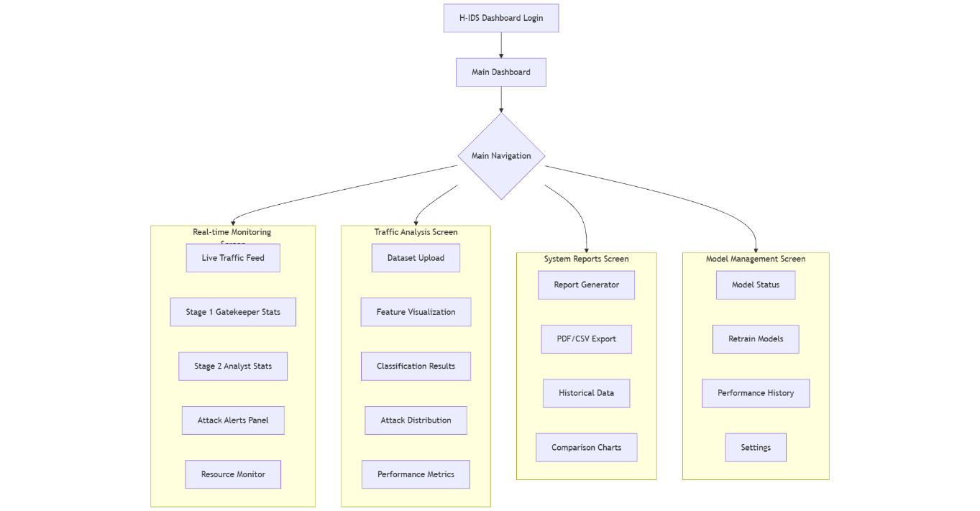

Dashboard snippets:

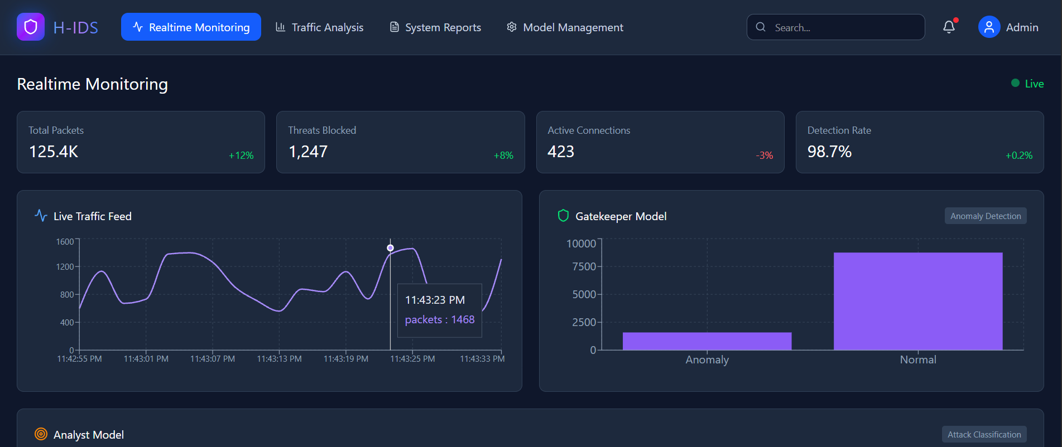

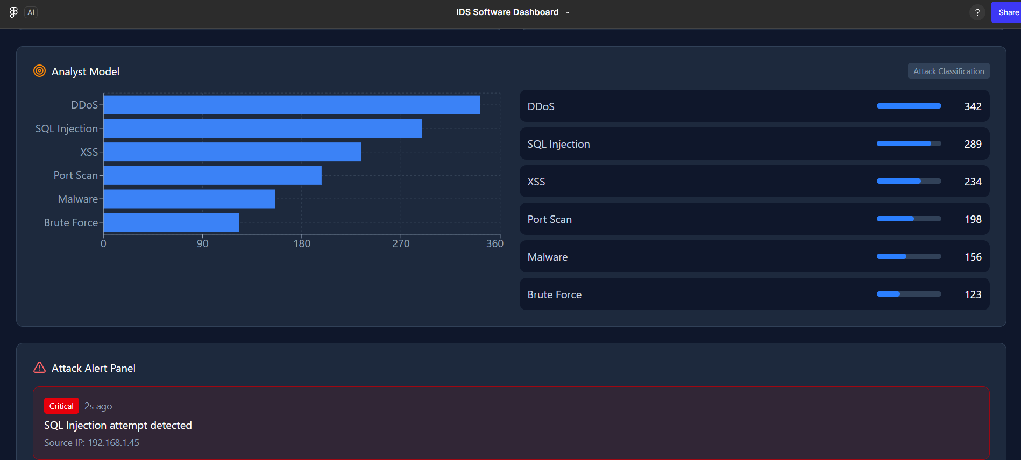

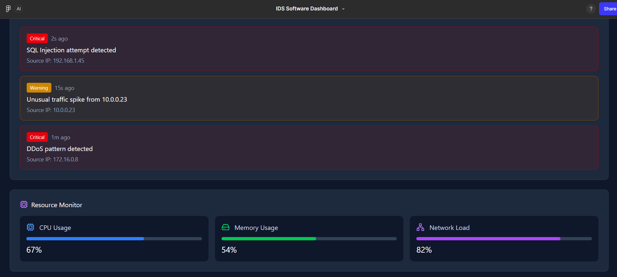

Prototype:

https://www.figma.com/make/FQeiBZAIRfajbAlEHIrAZ3/IDS-Software-Dashboard?p=f&t=ch3R8P21FgAaxSUe-0&fullscreen=1
Chapter 6 - Implementation

Add introductory paragraph.

Implementation Environment

Add sections as required.

Results and Discussion

Chapter 7 - Testing

Software Test Plan IEEE 829

Chapter 8 - Conclusion and Future Work

Add conclusion and future work, they can be separated in two sections or paragraphs.

References

Appendix A - Senior Project Summary Report

Project Title
Supervisor(s)
Team members: | Names  …………………………………………………………………  …………………………………………………………………  …………………………………………………………………  …………………………………………………………………  ………………………………………………………………… | Registration Numbers  …………………………  …………………………  …………………………  …………………………  …………………………
Project Deliverables | Indicate the deliverables of the project.
Local Impact | Briefly state the local impact of the project on the following aspects ; social, economical, environmental, any other relevant areas)
Global Impact | Briefly state the global impact of the project on the following aspects ; social, economical, environmental, any other relevant areas)
Team Organization | Describe the interdisciplinary/multidisciplinary team organization; list each member role and contributions. How each member evaluates a problem and performs duties within a team environment.
Ethical Considerations | Describe any ethical and/or safety issues related to the project (if exits)
Social Impact | Describe the social impact of the project.
Professional Responsibility | Illustrate how professional responsibility was taken into consideration while working on your project.
Standards | List the standards incorporated in your project
Realistic Constraints | List the realistic constraints you considered in your project

Supervisor Name | Signature

